

- Department Table

- Insert department Data

- Students Table
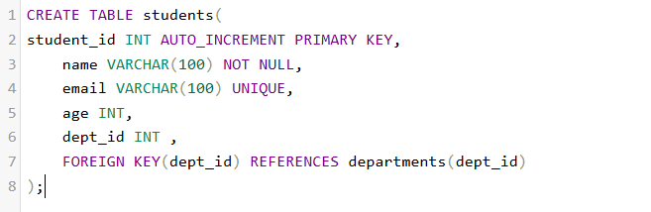

- Insert Student Data


- Courses Table

- Insert Courses Data

- Instructors Table


- Insert Instructors Data
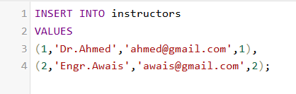
- Enrollments Table

- Insert Enrollment Data



- UPDATE-Update Student Name


- DELETE_ Delete Student



- Truncate Table


- Drop Table

- Alter Table

- Join Student + Courses

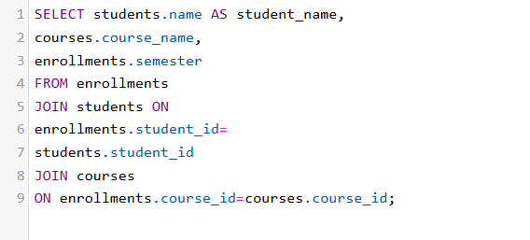
- Keys
1. Composite key;
A key consisting of more than one column.
Example:
Primary Key (student_id, course_id);
- Candidate Key
Any column that can be potentially be a primary key
Example:
- Student_id
- email

- Alternate Key
Candidate key not chosen as primary key
Example:
- Student_id = primary key
- Email=Alternate key

